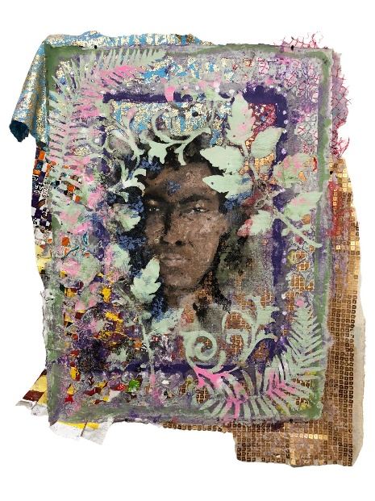
Ariel René Jackson & Lina Puerta:

Woven Land

July 14, 2022, to September 16, 2022
74 East 79th Street, 2D, New York, NY 10075
Tuesday – Friday
11 AM - 5 PM and by appointment

Ruiz-Healy Art is pleased to announce Ariel René Jackson & Lina Puerta: Woven Land. This is the first exhibition for both artists with Ruiz-Healy Art. Woven Land focuses on the relationship between humans, labor, and land. Ariel René Jackson utilizes found objects, printing, painting, and fiber work to create scenes and experiences from their cultural past. Lina Puerta creates collages, handmade-paper paintings and wall hangings to examine the relationship between nature and the human-made.
Lina Puerta, Pink & Gold Crop Worker, 2018, Mixed media on handmade paper, 27.5 x 23 in, 69.8 x 58.4 cm

An Artpace International Artist in Residence, Jackson’s practice considers land and landscape as sites of internal representation. Themes of colorism, nationality, and inheritance are also present in their work which incorporates different mediums. The artist’s mixed media paintings utilize organic material such as soil and chalk, while their fiber work integrates quilting traditions with silk screen printing. Writer and curator Lise Ragbir writes, “Jackson spent formative time in rural Louisiana where their grandparents were Black farmers. Bearing witness to their toil on family land inspired a curiosity about the notion of legacy, and the ways in which stories are passed down.”

Puerta’s work engages themes of food justice, xenophobia, hyper-consumerism, and ancestral knowledge. Featured in the exhibition are Puerta’s Latinx Farmworkers in the US tapestry series which combines cotton and linen paper pulp with recycled fabrics and paint. Latinx Farmworkers in the US highlights the extreme physical labor and hardship demanded by exploitative industrial agricultural systems, contrasted against the poetic life cycle of the crops themselves. Writer and curator Coco Dolle writes, “Puerta’s work falls into the global movement and legacy of Latin American artists and activists channeling their inner suffering and collective pathos or anger onto their works… At the core of these movements is a desperate yearning for freedom from European imperialism, machismo, and American big-stick diplomacy.”

Both Jackson and Puerta’s practice explore layers of imagination through painting, and craft aesthetics in

relation to the body, sustainability and cultural identity. Ariel René Jackson & Lina Puerta: Woven Land opens on Thursday, July 14th from 6 to 8 pm. Please contact the gallery at info@ruizhealyart.com or 646-833-7709 for details regarding our opening night reception, high-resolution images, and more information about this exhibition.

About the Artists
Ariel René Jackson is a Black creole anti-disciplinary artist whose practice considers land and landscape as sites of internal representation. Themes of transformation are embedded in their interest and application of repurposed imagery and objects, video, sound, and performance. The artist received their MFA at the University of Texas at Austin, Austin, TX where they currently live and work. Their work has been shown nationally and internationally at various galleries and institutions such as Museum of Modern Art, New York, NY; Women & Their Work, Austin, TX; Artpace, San Antonio, TX; Digital Arts Resource Centre, Ottawa, Canada; Dallas Contemporary, Dallas, TX; Jacob Lawrence Gallery, Seattle, WI; Contemporary Art Center, New Orleans, LA; Depaul Art Museum, Chicago, IL; Rhode Island School of Design Museum, Providence, RI among others.

Lina Puerta creates mixed media sculptures, installations, collages, handmade-paper paintings and wall hangings by combining a wide range of materials, from artificial plants and paper pulp to found, personal and recycled objects. The artist was born in New Jersey, raised in Colombia, and lives and works in New York City. Puerta holds an MS in Art Education from The City University of New York and has exhibited nationally and internationally. She has been honored with numerous awards such as the New York Foundation for the Arts Fellowship in Crafts/Sculpture, New York, NY; Artist-in-Residence at the Joan Mitchell Center, New Orleans, LA; Dieu Donné Workspace Residency, New York, NY; Kohler Arts Industry Residency, Sheboygan, WI among others.

About Ruiz-Healy Art
Founded in San Antonio, TX in 2006 Ruiz-Healy Art represents an international roster of artists and places emphasis on Latinx and Latin American artists, as well as working with prominent Texas-based artists. Biculturalism and identity discourse plays an important role in several of the artists that we collaborate with. In the spring of 2019, Ruiz-Healy Art opened a gallery space in the Upper East Side of New York City that works in tandem with the San Antonio gallery as a platform to disseminate the artist’s work. The continuous investments in these underrepresented areas have remained a longstanding signature of the gallery program.

