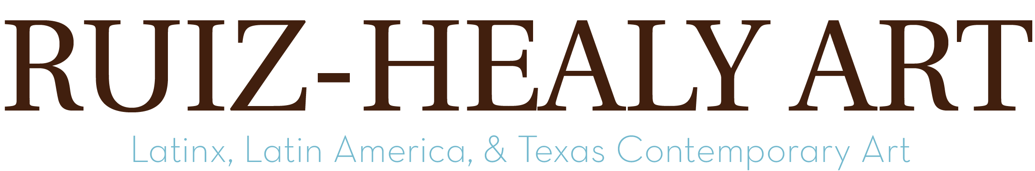

Consuelo Jimenez Underwood:
The Armory Show (Focus Section)

Ruiz-Healy Art is pleased to present Consuelo Jimenez Underwood at the Armory Show 2023. Jimenez Underwood has been exhibiting her work since the 1980s, choosing to focus on the fiber arts at a time when weaving was considered “craft,” not “art.” As the daughter of a Huichol-descended father who weaved and a Mexican-American mother who embroidered, it has always been important to the artist to continue these ancestral practices and insist on their legitimacy in the artistic sphere. Her initial goal as an artist was to become a “footnote in history,” but in recent years she has far surpassed her ambition. In 2022, Duke University Press published an anthology on her decades-long career, titled Consuelo Jimenez Underwood: Art, Weaving, Vision, and she was awarded the Latinx Artist Fellowship the same year. With this broad recognition, she thinks of her remaining time in this world as “the parade.”

The works presented span from the early 2000s to the summer of 2023 and showcase Jimenez Underwood’s technical skills in weaving and mixed media. She is well-known for her innovative use of barbed wire, safety pins, yellow caution tape, and caution signs, which reflect perhaps the most central theme in her work: the U.S.-Mexico border. Growing up along the Calexico, CA–Mexicali, MX border, the artist moved back and forth between family homes on either side of the frontera, and on more than one occasion was separated from her father–who was undocumented in the U.S.–when he was deported. The beauty of her work is a conscious strategy to discuss difficult border topics such as violence, the separation of families, and environmental destruction, but border subjects are not monolithic in her work. Stories of survival and growth along the border carry equal importance and cause for reflection.

While Jimenez Underwood’s artworks are technically tight and aesthetically beautiful, their content is just as important. Every stitch is guided by lifelong reflections on a range of complex subjects. The artist states: “My work is a reflection of personal border experiences: the interconnectedness of societies, insisting on beauty in struggle, and celebrating the notion of ‘seeing’ this world through my tri-cultural lens. Engaging materials, which reflect a contemporary hyper-modern sensitivity, are interwoven to create large-scale fiber art that is inspired in equal measures by land, politics and Spirit.”

About the Artist

Consuelo Jimenez Underwood was born in Sacramento, California. She received her BA and MA from San Diego State University, San Diego, CA. In 1987, Jimenez Underwood received an MFA in Art from San Jose University, San Jose, CA, where she immediately assumed the role of Professor and Director of the Fiber Area for more than two decades. In 2022, the artist was awarded the Latinx Artist Fellowship, a first-of-its-kind initiative that recognizes fifteen of the most compelling Latinx visual artists working in the United States today. She is the subject of Consuelo Jimenez Underwood: Art, Weaving Vision (2022), a comprehensive analysis of her work and impact on feminist textile art history published by Duke University Press.

Her work is featured in numerous permanent collections: Smithsonian American Art Museum, Washington, DC; Los Angeles County Museum of Art (LACMA), Los Angeles, CA; National Museum of Mexican Art, Chicago, IL; Mexican Fine Art Center Museum, Chicago, IL; Museum of Arts and Design, New York, NY; National Hispanic Center for The Arts, Albuquerque, NM; Crystal Bridges Museum of American Art, Bentonville, AR; Oakland Museum of California; Oakland, CA, among others.

About Ruiz-Healy Art
Founded in 2006 in San Antonio, Texas, Ruiz-Healy Art specializes in contemporary works of art and represents an international roster of artists with an emphasis on Latinx, Latin American, and prominent Texas-based artists. With galleries in San Antonio, TX and New York, NY, Ruiz-Healy Art's continuous investments in these underrepresented areas have remained a longstanding signature of the gallery program.

