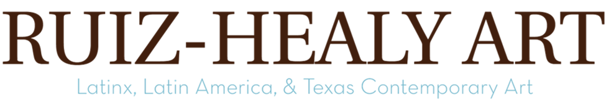
Ruiz-Healy Art is pleased to present Contemporary Bodegones, a group exhibition of works by Pedro Diego Alvarado, Yvette Mayorga, Eva Marengo Sanchez, Vick Quezada, and Chuck Ramírez, on view from May 9th to September 6th, 2024, at our New York City gallery. An opening reception will be held on May 9th from 6:00 to 8:00 pm. Contemporary Bodegones brings together works related to the featured artists’ individual lived histories and explores how food interlinks us with both identity and broader social issues.

Pedro Diego Alvarado draws a compelling parallel between the historical context of the Dutch Golden Age and contemporary points at issue. Alvarado’s work highlights a deep engagement with themes like urbanization, globalization, and international trade, echoing the social and economic factors that originally fueled the popularity of still-life genres in the Northern and Spanish Netherlands, with a growing emphasis on domesticity and personal possessions. The inclusion of fruits such as pomegranates, zapote, and naranjas Chinas in Alvarado’s paintings serves multiple symbolic purposes, reflecting the influence of global trade on local traditions. To him, the wide array of tropical fruits, their cultivation, and their presence in everyday life “are a part of what it is to be Mexican.” Alvarado invites viewers to reflect on the ongoing dialogue between the past and the present, between local identities and global currents.

Similarly, Eva Marengo Sanchez shares Alvarado’s perception, illustrating the links between food, culture, and geography and how food is quintessential to contemporary San Antonio. “I love food and its power to carry memory, create community, and shape identity, and as the subject of my work, it’s how I express my family history, life in San Antonio, and contemporary Mexican American culture.”

Chuck Ramirez’s Coconuts series transforms the slur “coconut”—brown on the outside, white on the inside—and converts degrading name-calling into the proud tag of another, more layered identity. Ramirez recognizes photography’s use in projecting mass-culture representations of identity, even as he undercuts the stereotyped slurs in identity politics and the related artistic and historical canon.

Utilizing the color pink, Yvette Mayorga subverts the notions of girlhood and femininity to deconstruct the notion of the American Dream. Mayorga’s work fuses Rococo, Maximalist, and religious iconography. Mayorga states, “It makes sense for pink and Rococo to be powerful in my world, a tool of seduction to draw people in and then force them to sit with the work and find out what it’s about.” In her painting, Tweety Hot Lovers (After Century Vase c. 1876), the thick acrylic paint mimics the texture of icing. It creates a form after The Century Vase, which originally included bison-head handles and a profile of George Washington. Armed with pink glitz and glam decoration, golden chains, and a Tweety bird, Mayorga challenges this powerful American patriotic symbol.

Vick Quezada reworks themes surrounding the US-Mexican border, ranging from immigration and colonialism to capitalism, mass production, and the constitutional system. ICE Remains, and Stainless Remains are ceramic hand-pressed stylized stainless trays inspired by the cafeteria trays found at Fort Hood, now named Fort Cavazos, in Texas. The form of the trays imitates a product of industrialization, questioning established economic concepts of “value,” but the hand-made quality and materials link them to the Earth. These trays illustrate colonial histories endured by Mestizx-Indigenous people. The artist’s choice of medium emphasizes their call for land rights and reparations from colonialism while honoring and embracing the ceramic traditions of the Indigenous people of Northern Mexico.

About Ruiz-Healy Art

Founded in San Antonio, TX, in 2006, Ruiz-Healy Art represents an international roster of artists, emphasizing Latinx and Latin American artists and working with prominent Texas-based artists. Biculturalism and identity discourse are important in several artists we collaborate with. In the spring of 2019, we opened a gallery space in the Upper East Side of New York City that works in tandem with the gallery in San Antonio as a platform to disseminate the artist’s work. The continuous investments in these under-represented areas have remained a longstanding signature of the gallery program. The gallery is recognized for its success in placing works by our artists in prestigious museum collections ranging from the Museum of Modern Art, New York, Whitney Museum of American Art, the Smithsonian Institution, the LA County Museum of Art, the San Francisco Museum of Modern Art, San Antonio Museum of Art, McNay Art Museum, Museum of Fine Arts, Houston, and many others.

